EXPERIMENT 11:
PROGRAM CODE:

# ==============================================================
# BIG DATA PROCESSING FOR IoE SENSOR DATA
# Hadoop vs Apache Spark performance analysis
# Google Colab simulation
# ==============================================================

import numpy as np
import pandas as pd
import matplotlib.pyplot as plt
import time
import os

np.random.seed(24)

print("=" * 85)
print("BIG DATA PROCESSING FOR IoE SENSOR DATA")
print("HADOOP vs APACHE SPARK PERFORMANCE ANALYSIS")
print("=" * 85)

# --------------------------------------------------------------
# 1. GENERATE IoE SENSOR DATA
# --------------------------------------------------------------
print("\n1. IoE SENSOR DATA GENERATION")

num_records = 100_000

start_generation = time.perf_counter()

df = pd.DataFrame({
"sensor_id": np.random.randint(1, 101, num_records),
"timestamp": pd.date_range(
"2026-01-01", periods=num_records, freq="s"
),
"temperature_C": np.random.normal(28, 4, num_records),
"humidity_percent": np.random.uniform(30, 90, num_records),
"pressure_hPa": np.random.normal(1013, 5, num_records),
"region": np.random.choice(
["North", "South", "East", "West"], num_records
)
})

df["temperature_C"] = df["temperature_C"].round(2)
df["humidity_percent"] = df["humidity_percent"].round(2)
df["pressure_hPa"] = df["pressure_hPa"].round(2)

generation_time = time.perf_counter() - start_generation

print("Data generated successfully.")
print("Total records:", len(df))
print("Number of sensors:", df["sensor_id"].nunique())
print("Number of regions:", df["region"].nunique())
print("\nSample records:")
print(df.head(10).to_string(index=False))

# --------------------------------------------------------------
# 2. DATA INGESTION
# --------------------------------------------------------------
print("\n" + "=" * 85)
print("2. IoE DATA INGESTION")
print("=" * 85)

csv_path = "/content/ioe_sensor_data.csv"

ingestion_start = time.perf_counter()
df.to_csv(csv_path, index=False)
df_ingested = pd.read_csv(csv_path)
ingestion_time = time.perf_counter() - ingestion_start

file_size_mb = os.path.getsize(csv_path) / (1024 * 1024)

print("CSV file created:", csv_path)
print("Records ingested:", len(df_ingested))
print("File size (MB):", round(file_size_mb, 2))
print("Ingestion time (seconds):", round(ingestion_time, 4))
print("Ingestion status:",
"SUCCESS" if len(df_ingested) == num_records else "FAILED")

# --------------------------------------------------------------
# 3. BATCH PROCESSING
# --------------------------------------------------------------
print("\n" + "=" * 85)
print("3. BATCH PROCESSING OF SENSOR DATA")
print("=" * 85)

processing_start = time.perf_counter()

# Aggregate sensor measurements by region.
region_summary = df_ingested.groupby("region").agg(
record_count=("sensor_id", "count"),
average_temperature=("temperature_C", "mean"),
average_humidity=("humidity_percent", "mean"),
average_pressure=("pressure_hPa", "mean"),
maximum_temperature=("temperature_C", "max")
).reset_index()

# Detect unusually high temperature readings.
high_temperature = df_ingested[
df_ingested["temperature_C"] > 35
].copy()

# Count records by sensor.
sensor_summary = df_ingested.groupby("sensor_id").agg(
records=("sensor_id", "count"),
average_temperature=("temperature_C", "mean")
).reset_index()

processing_time = time.perf_counter() - processing_start

print("Batch processing completed successfully.")
print("\nRegional aggregation:")
print(region_summary.round(2).to_string(index=False))

print("\nSensor summary preview:")
print(sensor_summary.head(10).round(2).to_string(index=False))

print("\nHigh-temperature records:", len(high_temperature))
print("Processing time (seconds):", round(processing_time, 4))

# Save processed outputs.
region_summary.to_csv("/content/region_summary.csv", index=False)
sensor_summary.to_csv("/content/sensor_summary.csv", index=False)
high_temperature.to_csv("/content/high_temperature_alerts.csv", index=False)

# --------------------------------------------------------------
# 4. LOCAL PROCESSING METRICS
# --------------------------------------------------------------
print("\n" + "=" * 85)
print("4. EXECUTION TIME AND THROUGHPUT")
print("=" * 85)

local_throughput = len(df_ingested) / max(processing_time, 1e-9)

local_metrics = pd.DataFrame({
"Metric": [
"Records processed",
"Data size (MB)",
"Data ingestion time (s)",
"Batch processing time (s)",
"Processing throughput (records/s)"
],
"Value": [
len(df_ingested),
round(file_size_mb, 2),
round(ingestion_time, 4),
round(processing_time, 4),
round(local_throughput, 2)
]
})

print(local_metrics.to_string(index=False))

# --------------------------------------------------------------
# 5. HADOOP vs APACHE SPARK COMPARISON
# --------------------------------------------------------------
print("\n" + "=" * 85)
print("5. HADOOP vs APACHE SPARK PERFORMANCE COMPARISON")
print("=" * 85)

# IMPORTANT:
# These are illustrative estimates, not actual Hadoop or Spark runs.
# Both frameworks are modeled using assumed startup overheads and
# processing rates. Change these assumptions for scenario analysis.

frameworks = ["Hadoop MapReduce (modeled)", "Apache Spark (modeled)"]

# Illustrative parameters for a distributed cluster.
# Startup time is fixed overhead; rate is assumed records/second.
framework_parameters = {
"Hadoop MapReduce (modeled)": {
"startup_seconds": 8.0,
"records_per_second": 25000
},
"Apache Spark (modeled)": {
"startup_seconds": 3.0,
"records_per_second": 50000
}
}

comparison_results = []

for framework in frameworks:
p = framework_parameters[framework]

estimated_time = (
p["startup_seconds"] +
len(df_ingested) / p["records_per_second"]
)

estimated_throughput = len(df_ingested) / estimated_time

comparison_results.append([
framework,
round(estimated_time, 3),
round(estimated_throughput, 2),
p["startup_seconds"],
p["records_per_second"]
])

comparison_df = pd.DataFrame(
comparison_results,
columns=[
"Framework",
"Estimated Execution Time (s)",
"Estimated Throughput (records/s)",
"Assumed Startup Overhead (s)",
"Assumed Processing Rate (records/s)"
]
)

print("Illustrative distributed-processing model:")
print(comparison_df.to_string(index=False))

hadoop_time = comparison_df.iloc[0]["Estimated Execution Time (s)"]
spark_time = comparison_df.iloc[1]["Estimated Execution Time (s)"]

time_saved = hadoop_time - spark_time
time_improvement = (time_saved / hadoop_time) * 100

hadoop_tp = comparison_df.iloc[0][
"Estimated Throughput (records/s)"
]
spark_tp = comparison_df.iloc[1][
"Estimated Throughput (records/s)"
]

throughput_improvement = (
(spark_tp - hadoop_tp) / hadoop_tp
) * 100

print("\nCOMPARISON SUMMARY")
print("-" * 45)
print("Modeled execution time saved by Spark:",
round(time_saved, 2), "seconds")
print("Modeled execution-time reduction:",
round(time_improvement, 2), "%")
print("Modeled throughput improvement:",
round(throughput_improvement, 2), "%")

# --------------------------------------------------------------
# 6. EXECUTION TIME COMPARISON GRAPH
# --------------------------------------------------------------
print("\n" + "=" * 85)
print("6. EXECUTION TIME COMPARISON GRAPH")
print("=" * 85)

plt.figure(figsize=(9, 5))
plt.bar(
comparison_df["Framework"],
comparison_df["Estimated Execution Time (s)"]
)
plt.title("Modeled Hadoop vs Spark Execution Time")
plt.ylabel("Estimated execution time (seconds)")
plt.xlabel("Processing framework")
plt.grid(axis="y", alpha=0.3)
plt.xticks(rotation=10)
plt.tight_layout()
plt.show()

# --------------------------------------------------------------
# 7. THROUGHPUT COMPARISON GRAPH
# --------------------------------------------------------------
print("\n" + "=" * 85)
print("7. THROUGHPUT COMPARISON GRAPH")
print("=" * 85)

plt.figure(figsize=(9, 5))
plt.bar(
comparison_df["Framework"],
comparison_df["Estimated Throughput (records/s)"]
)
plt.title("Modeled Hadoop vs Spark Throughput")
plt.ylabel("Records processed per second")
plt.xlabel("Processing framework")
plt.grid(axis="y", alpha=0.3)
plt.xticks(rotation=10)
plt.tight_layout()
plt.show()

# --------------------------------------------------------------
# 8. IoE SENSOR DATA VISUALIZATION
# --------------------------------------------------------------
print("\n" + "=" * 85)
print("8. IoE SENSOR DATA ANALYSIS")
print("=" * 85)

plt.figure(figsize=(10, 5))
plt.bar(
region_summary["region"],
region_summary["average_temperature"]
)
plt.title("Average Temperature by Region")
plt.xlabel("Region")
plt.ylabel("Average temperature (°C)")
plt.grid(axis="y", alpha=0.3)
plt.tight_layout()
plt.show()

plt.figure(figsize=(10, 5))
plt.hist(
df_ingested["temperature_C"],
bins=30,
edgecolor="black"
)
plt.title("IoE Sensor Temperature Distribution")
plt.xlabel("Temperature (°C)")
plt.ylabel("Number of records")
plt.grid(axis="y", alpha=0.3)
plt.tight_layout()
plt.show()

# --------------------------------------------------------------
# 9. SAVE FINAL COMPARISON RESULTS
# --------------------------------------------------------------
comparison_df.to_csv(
"/content/hadoop_spark_comparison.csv", index=False
)
local_metrics.to_csv(
"/content/local_processing_metrics.csv", index=False
)

print("\n" + "=" * 85)
print("9. FINAL PROJECT SUMMARY")
print("=" * 85)

print("1. IoE sensor data generated:", len(df_ingested), "records")
print("2. Data ingestion completed successfully.")
print("3. Batch aggregation and temperature anomaly filtering completed.")
print("4. Execution time and throughput calculated.")
print("5. Hadoop and Spark modeled comparison completed.")
print("6. Performance graphs generated.")
print("7. CSV results saved in /content.")

print("\nOUTPUT FILES")
print(" - ioe_sensor_data.csv")
print(" - region_summary.csv")
print(" - sensor_summary.csv")
print(" - high_temperature_alerts.csv")
print(" - hadoop_spark_comparison.csv")
print(" - local_processing_metrics.csv")

print("\nIMPORTANT:")
print("Hadoop/Spark results are modeled estimates, not actual framework")
print("benchmarks. A real benchmark requires installing and executing")
print("Hadoop and Spark on a configured environment or cluster.")
OUTPUT:
=====================================================================================
BIG DATA PROCESSING FOR IoE SENSOR DATA
HADOOP vs APACHE SPARK PERFORMANCE ANALYSIS
=====================================================================================

1. IoE SENSOR DATA GENERATION
Data generated successfully.
Total records: 100000
Number of sensors: 100
Number of regions: 4

Sample records:
sensor_id timestamp temperature_C humidity_percent pressure_hPa region
35 2026-01-01 00:00:00 27.12 48.68 1010.42 West
4 2026-01-01 00:00:01 33.71 54.76 1026.35 South
65 2026-01-01 00:00:02 24.97 44.89 1011.83 South
88 2026-01-01 00:00:03 27.73 64.66 1007.72 West
18 2026-01-01 00:00:04 34.60 64.95 1020.74 West
18 2026-01-01 00:00:05 27.11 66.67 1008.60 North
2 2026-01-01 00:00:06 25.36 76.69 1013.24 North
80 2026-01-01 00:00:07 29.14 55.49 1013.12 North
5 2026-01-01 00:00:08 25.14 73.69 999.96 North
100 2026-01-01 00:00:09 28.87 32.52 1015.24 North

=====================================================================================
2. IoE DATA INGESTION
=====================================================================================
CSV file created: /content/ioe_sensor_data.csv
Records ingested: 100000
File size (MB): 4.59
Ingestion time (seconds): 0.8341
Ingestion status: SUCCESS

=====================================================================================
3. BATCH PROCESSING OF SENSOR DATA
=====================================================================================
Batch processing completed successfully.

Regional aggregation:
region record_count average_temperature average_humidity average_pressure maximum_temperature
East 24896 28.02 60.08 1013.01 44.46
North 25098 28.00 59.81 1012.95 44.81
South 24949 28.00 59.95 1013.01 43.79
West 25057 28.04 59.80 1012.95 42.53

Sensor summary preview:
sensor_id records average_temperature
1 1019 27.98
2 1079 27.97
3 973 27.93
4 988 27.98
5 1018 28.12
6 1043 27.96
7 961 28.14
8 1027 28.04
9 972 28.37
10 1037 27.88

High-temperature records: 4059
Processing time (seconds): 0.0402

=====================================================================================
4. EXECUTION TIME AND THROUGHPUT
=====================================================================================
Metric Value
Records processed 100000.0000
Data size (MB) 4.5900
Data ingestion time (s) 0.8341
Batch processing time (s) 0.0402
Processing throughput (records/s) 2486927.1600

=====================================================================================
5. HADOOP vs APACHE SPARK PERFORMANCE COMPARISON
=====================================================================================
Illustrative distributed-processing model:
Framework Estimated Execution Time (s) Estimated Throughput (records/s) Assumed Startup Overhead (s) Assumed Processing Rate (records/s)
Hadoop MapReduce (modeled) 12.0 8333.33 8.0 25000
Apache Spark (modeled) 5.0 20000.00 3.0 50000

COMPARISON SUMMARY
---------------------------------------------
Modeled execution time saved by Spark: 7.0 seconds
Modeled execution-time reduction: 58.33 %
Modeled throughput improvement: 140.0 %

=====================================================================================
6. EXECUTION TIME COMPARISON GRAPH
=====================================================================================
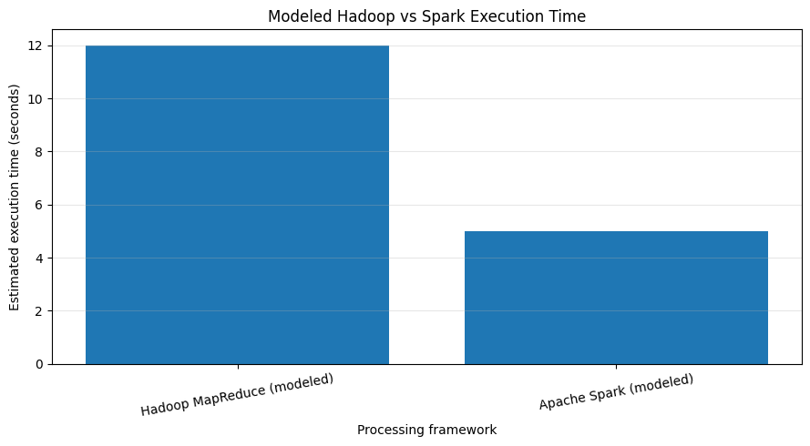

=====================================================================================
7. THROUGHPUT COMPARISON GRAPH
=====================================================================================
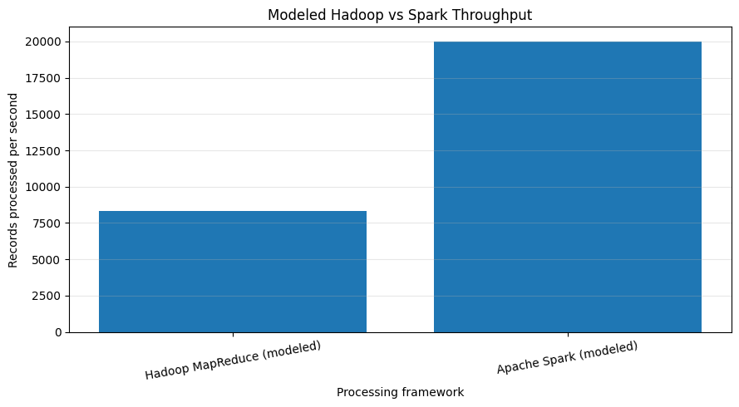

=====================================================================================
8. IoE SENSOR DATA ANALYSIS
=====================================================================================
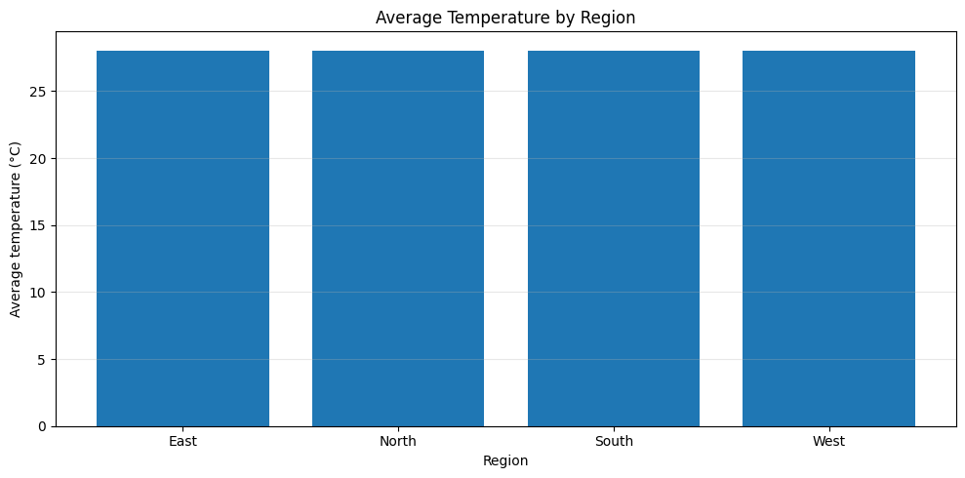
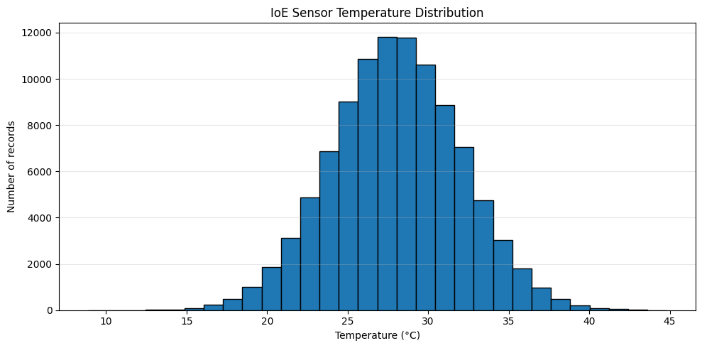

=====================================================================================
9. FINAL PROJECT SUMMARY
=====================================================================================
1. IoE sensor data generated: 100000 records
2. Data ingestion completed successfully.
3. Batch aggregation and temperature anomaly filtering completed.
4. Execution time and throughput calculated.
5. Hadoop and Spark modeled comparison completed.
6. Performance graphs generated.
7. CSV results saved in /content.

